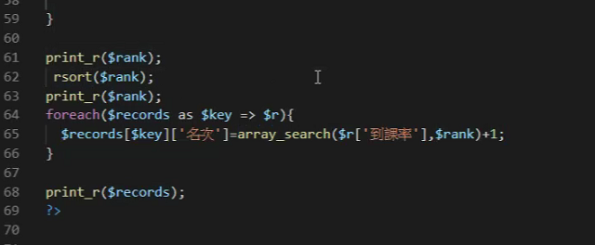

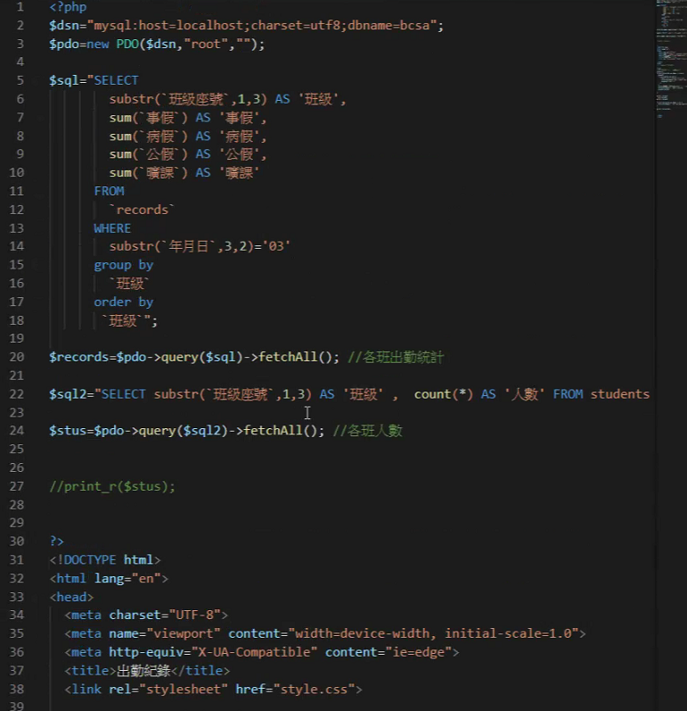

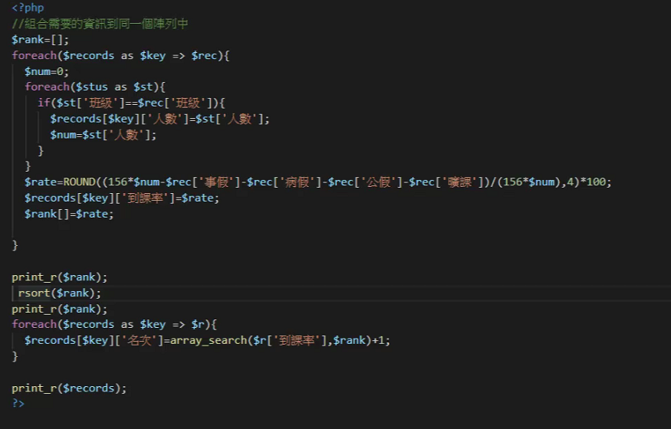

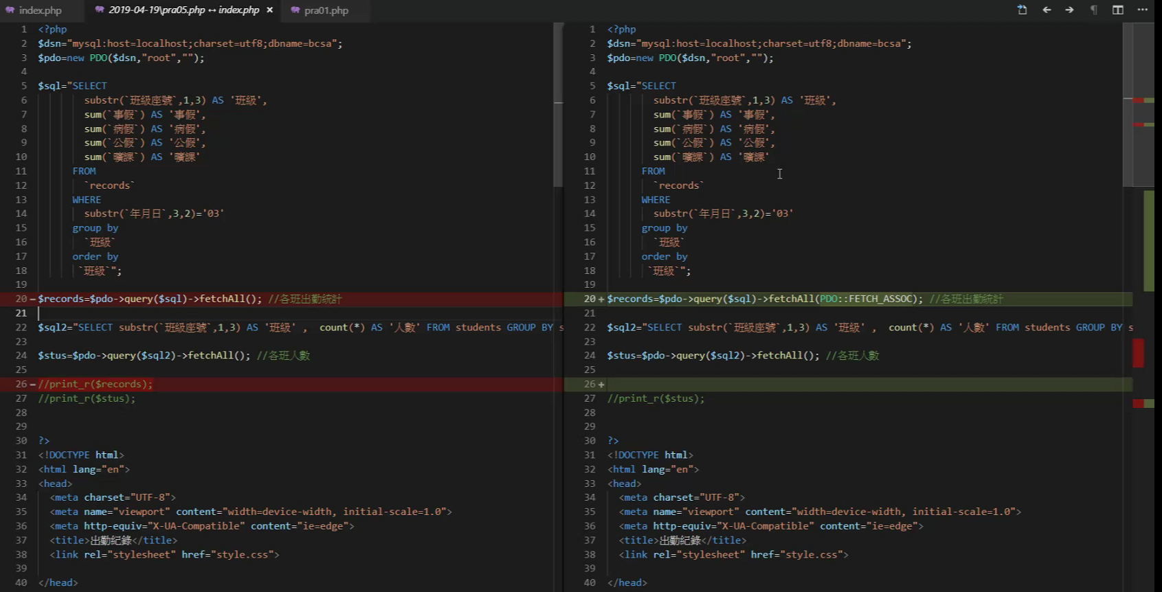

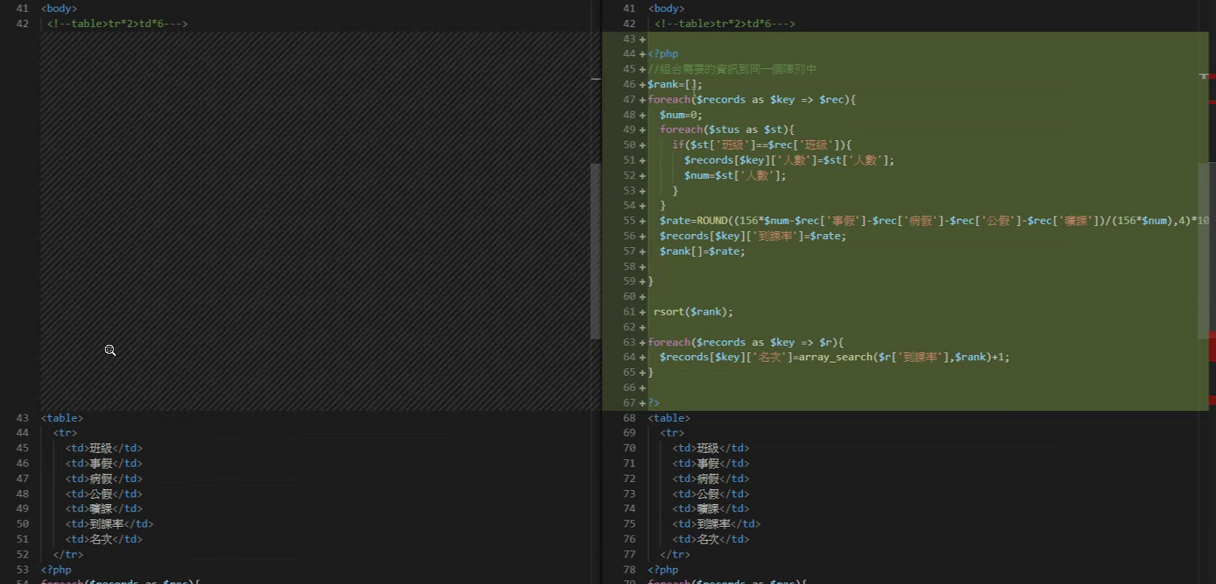

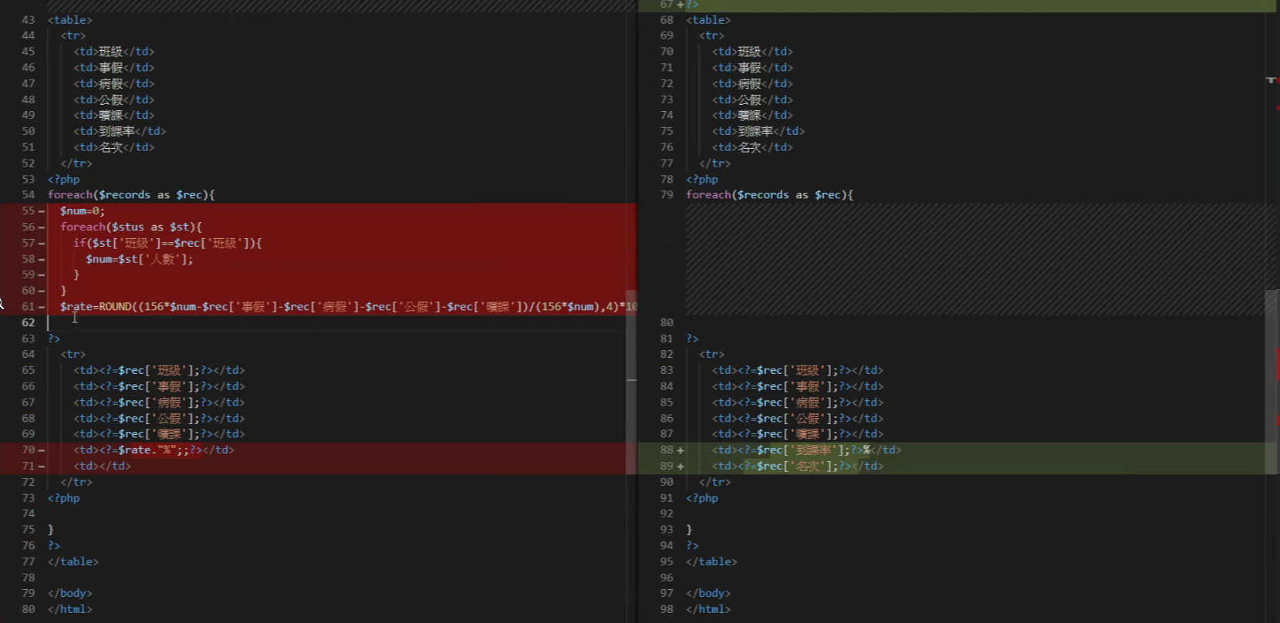

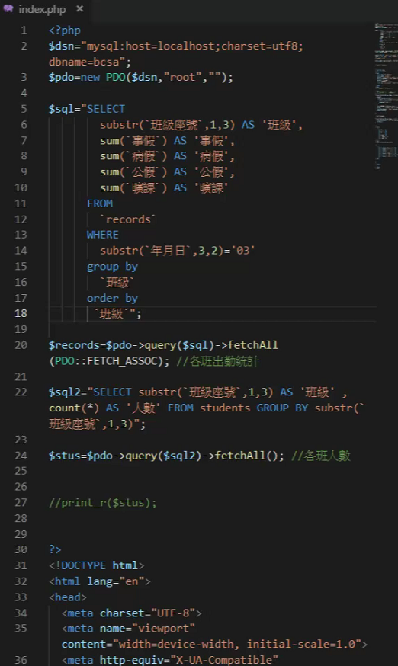

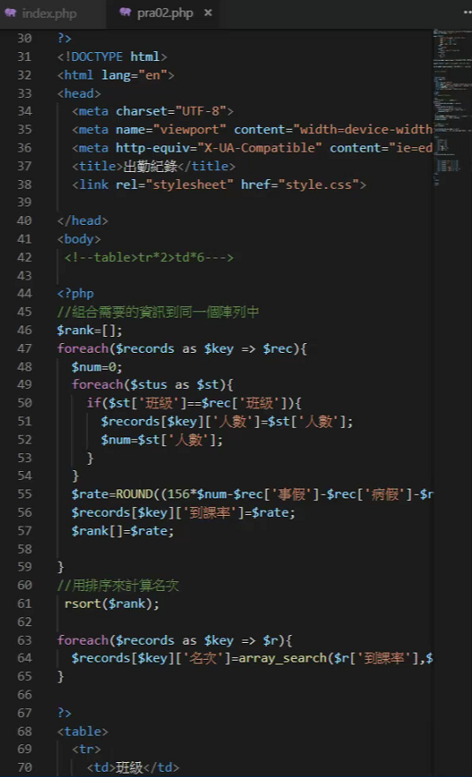

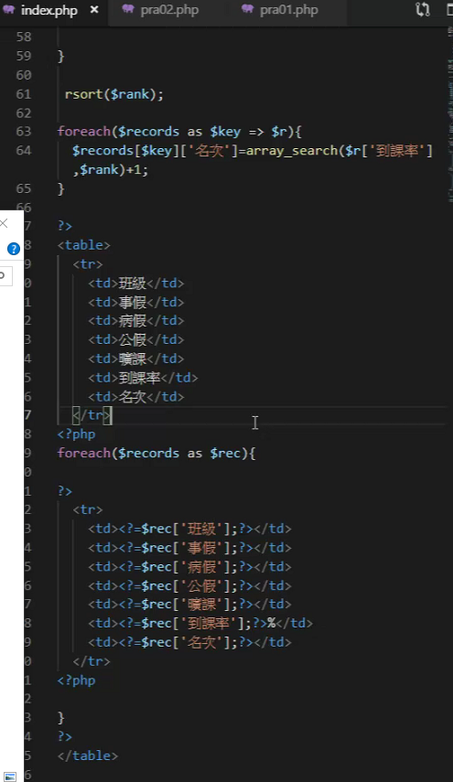

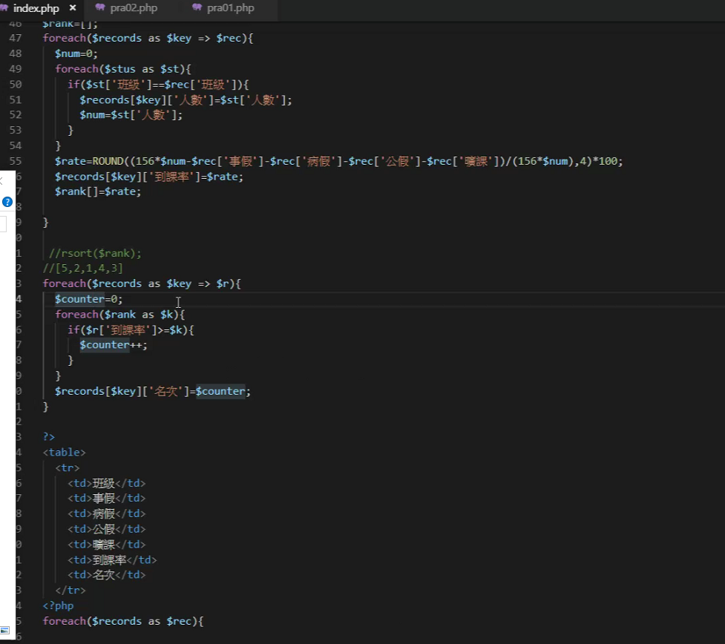

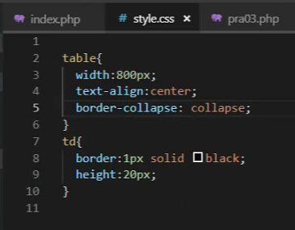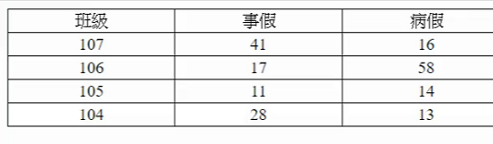

$records=$pdo->query($sql)->fetchAll(PDO::FETCH_ASSOC); //各班出勤統計

$records=$pdo->query($sql)->fetchAll(); //各班出勤統計

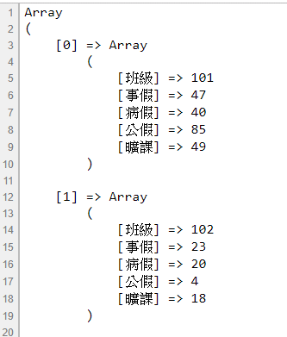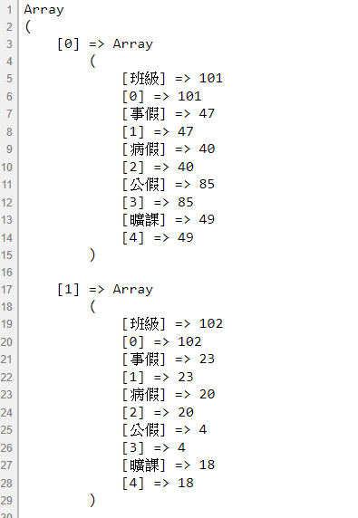

SELECT * FROM `records` WHERE substr(`年月日`,3,2)='03'

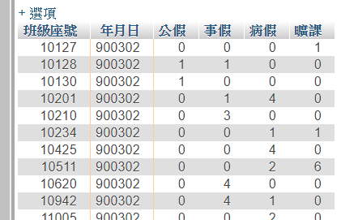

<http://ps.hsuweni.idv.tw/?p=5025>

**PDO::FETCH_ASSOC 返回以欄位名稱作為索引鍵(key)的陣列(array)**

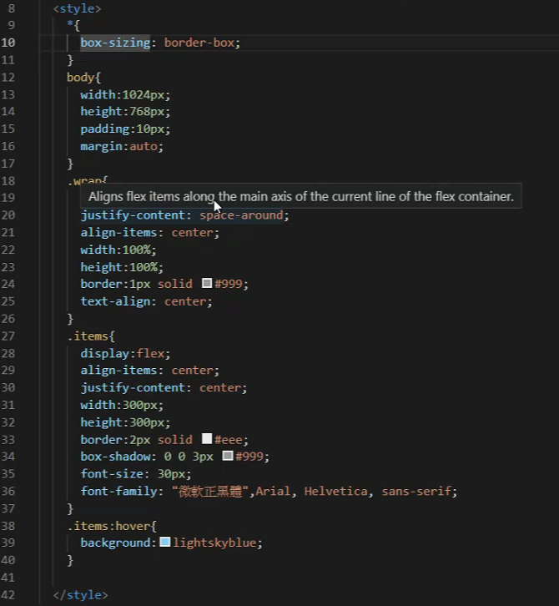

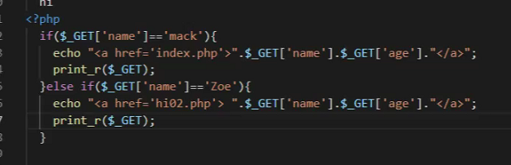

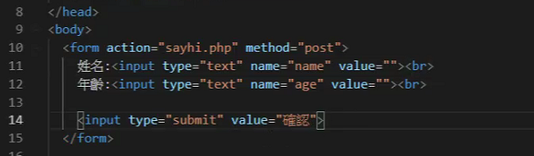

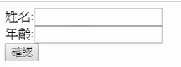

if($_GET['name']=='mack'){

echo "<a href='sayhi.php'>".$_GET['name'].$_GET['age']."</a>>" ;

}else if ($_GET['name']=='Zoe'){

echo "<a href='hi02.php'>".$_GET['name'].$_GET['age']."</a>";

}

